Ideation Phase
Define the Problem Statements

Date | 20/10/2026
Team ID | Shried Mandloi
Project Name | Electric Vehicle Market Performance & Insights
Maximum Marks | 2 Marks

Customer Problem Statements – EV Market Analysis
The customer problem statements identify the key challenges faced by Emily Johnson, an EV Market Strategy Director, while analysing the electric vehicle market. They focus on her goals, difficulties, underlying reasons, and emotions related to understanding market trends, comparing manufacturers, evaluating vehicle categories, and analysing battery technologies and customer satisfaction.
These problem statements help define the key requirements of the EV Market Performance Dashboard and ensure that the visualizations provide meaningful insights for strategic decision-making.

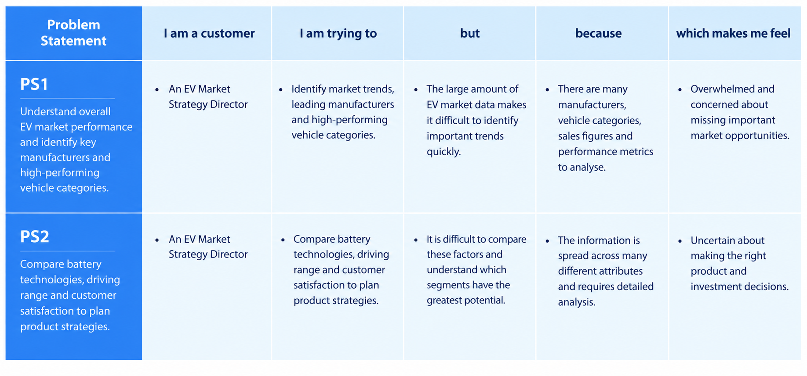
Problem Statement (PS) | I am (Customer) | I’m trying to | But | Because | Which makes me feel
PS-1 | An EV Market Strategy Director | identify market trends, leading manufacturers, and high-performing vehicle categories | the large amount of EV market data makes it difficult to identify important trends quickly | the information contains many manufacturers, vehicle categories, sales figures, and performance metrics | overwhelmed and concerned about missing important market opportunities
PS-2 | An EV Market Strategy Director | compare battery technologies, driving range, and customer satisfaction to plan product strategies | it is difficult to compare these factors and understand which segments have the greatest potential | the relevant information is spread across many different attributes and requires detailed analysis | uncertain about making the right product and investment decisions

